**Networking & Active Directory Domain Lab Full Report By: Oluwafemi Oroyemi**

**1. Server Setup and Initial Configuration**

I began by deploying a Windows Server VM and configuring it as the main domain controller for the lab environment.

**1.1 Rename Server to DC1**

After installation, the server was renamed to **DC1** and rebooted.

**1.2 Configure Static IP**

A static IP configuration was required before installing server roles.  
The server was assigned:

* **IP Address:** 10.0.0.4
* **Subnet Mask:** 255.255.255.0
* **Gateway:** 10.0.0.1
* **DNS:** 127.0.0.1 (self)

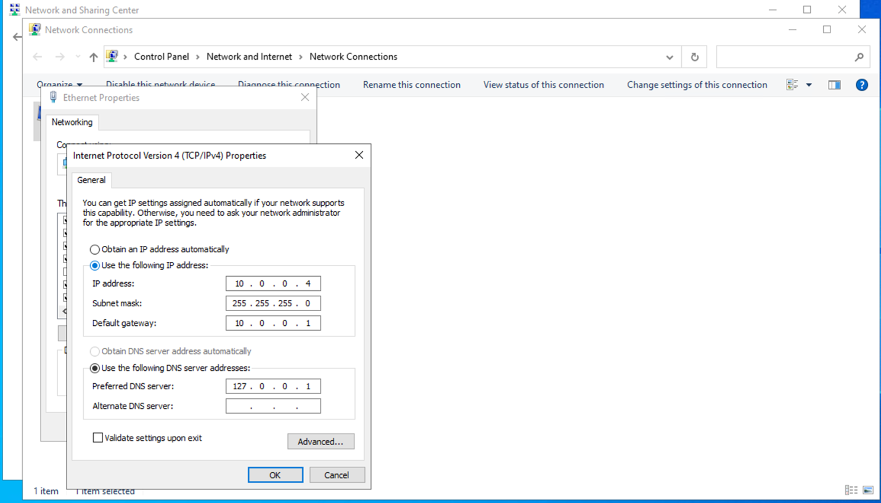  
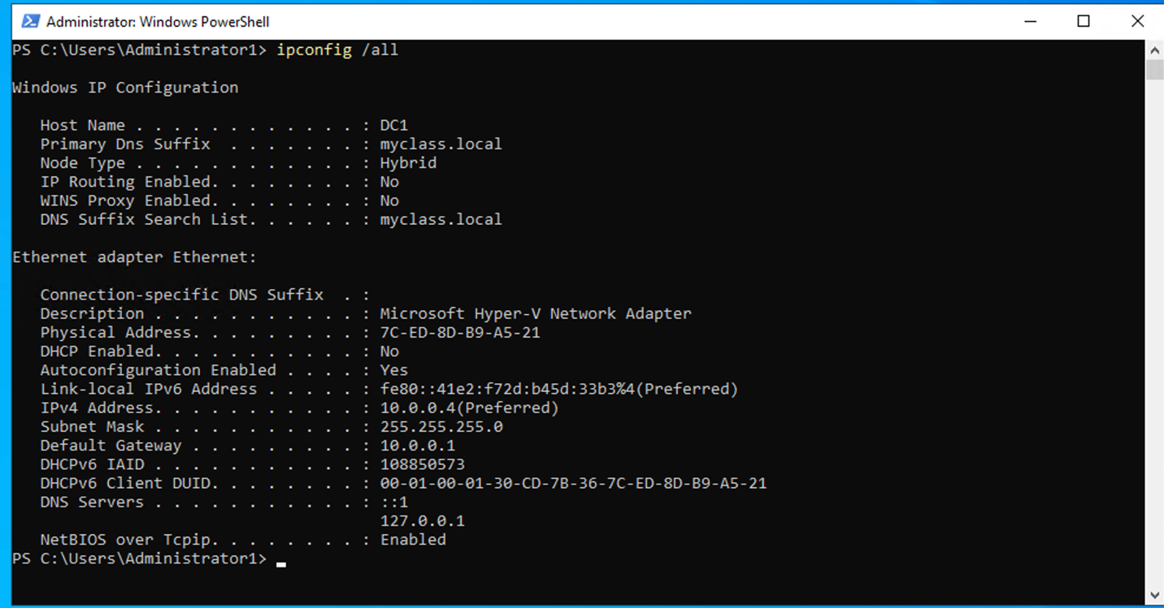

Server Manager confirmed the configuration:

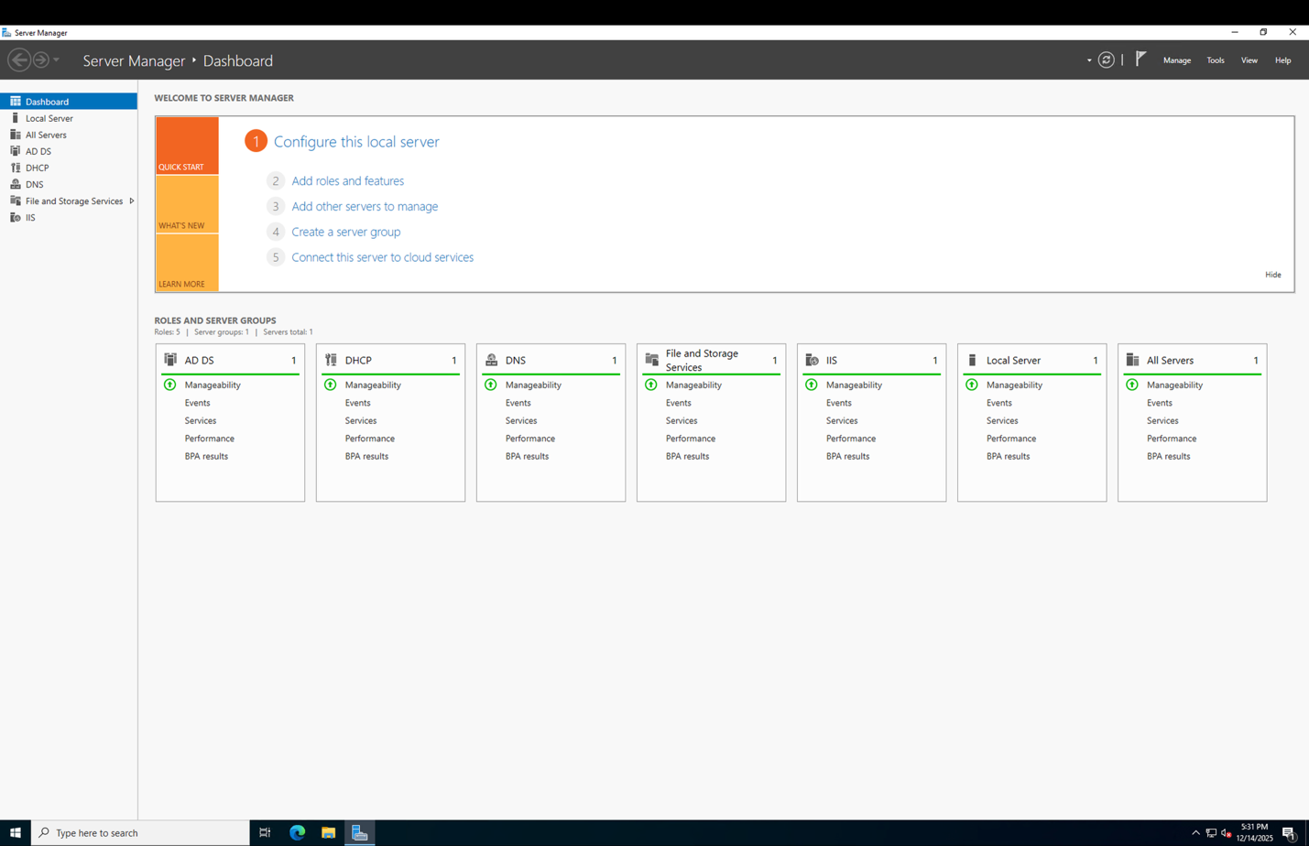

A validation warning appeared during the DNS/AD DS wizard. So I checked allow and that fixed the warning issue right away.

**1.3 Prepare for Active Directory Domain Services (AD DS) Installation**

The AD DS configuration wizard required choosing domain and forest functional levels.

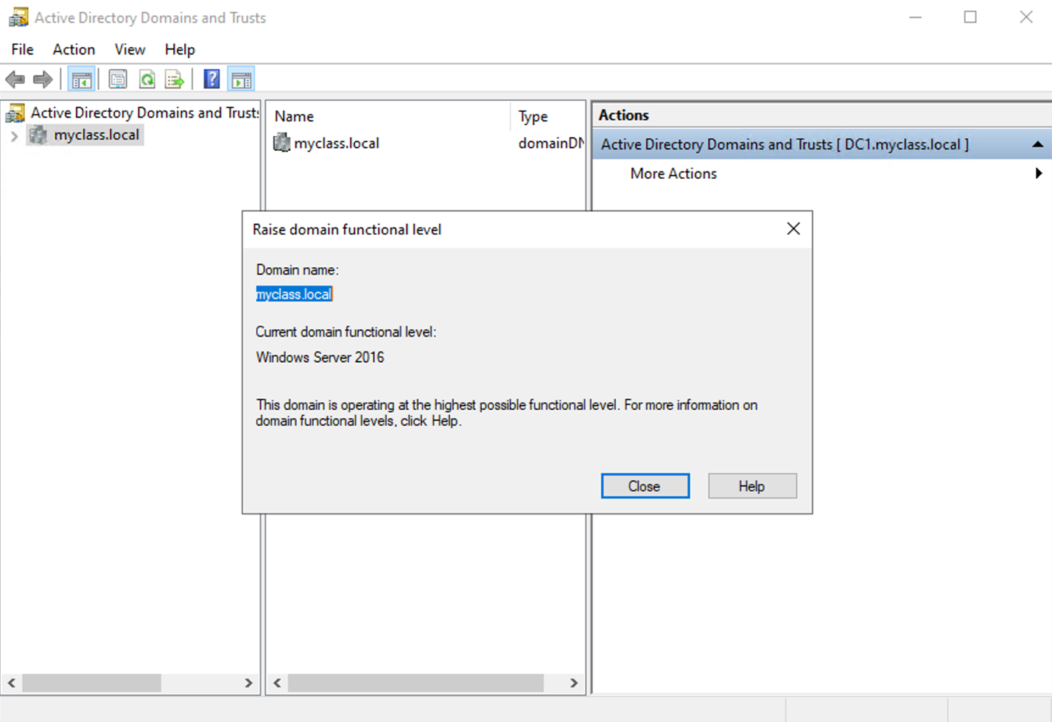  
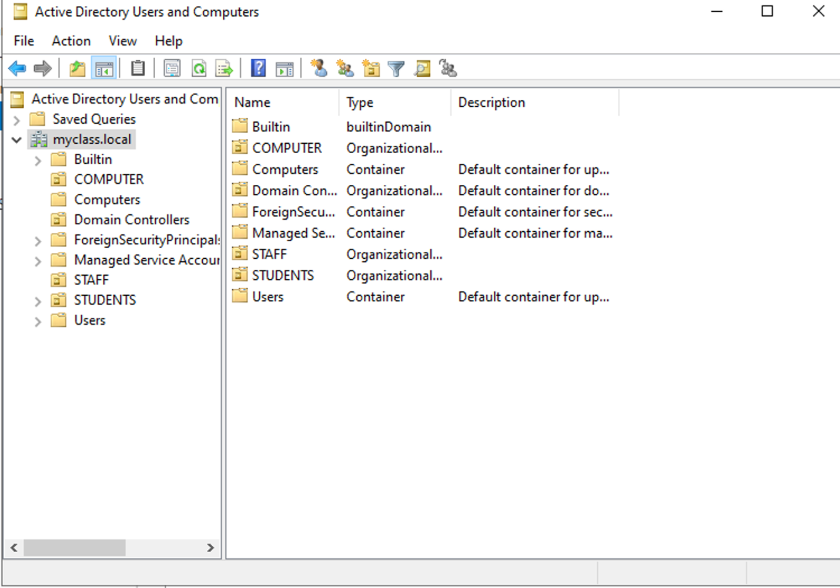

**2. Active Directory Domain Services Deployment**

**2.1 Promote Server to Domain Controller**

I created a new forest named:

➡️ **myclass.local**

The following options were enabled:

* DNS Server
* Global Catalog
* Windows Server 2016 forest/domain functional levels

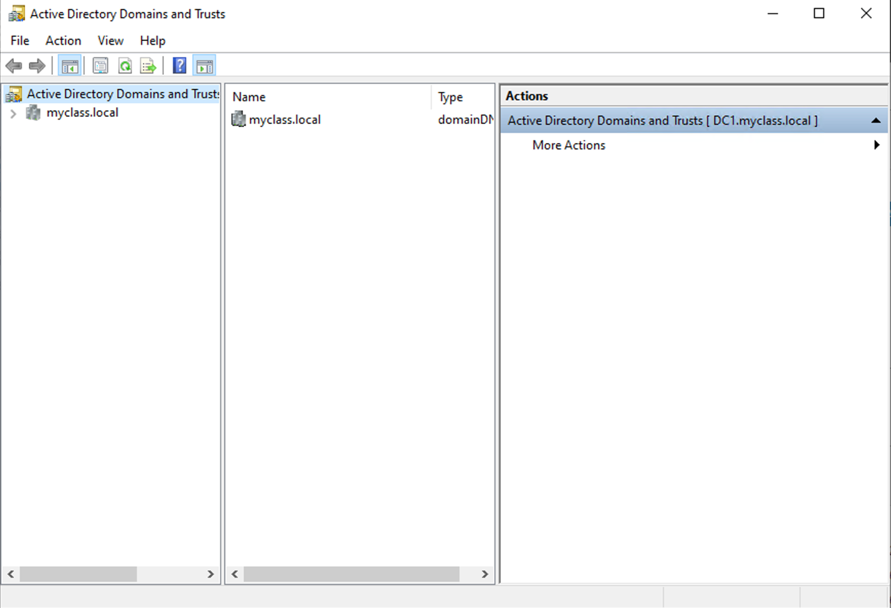**2.2 Domain Controller Installed Successfully**

After applying the settings and rebooting, the domain controller became active.

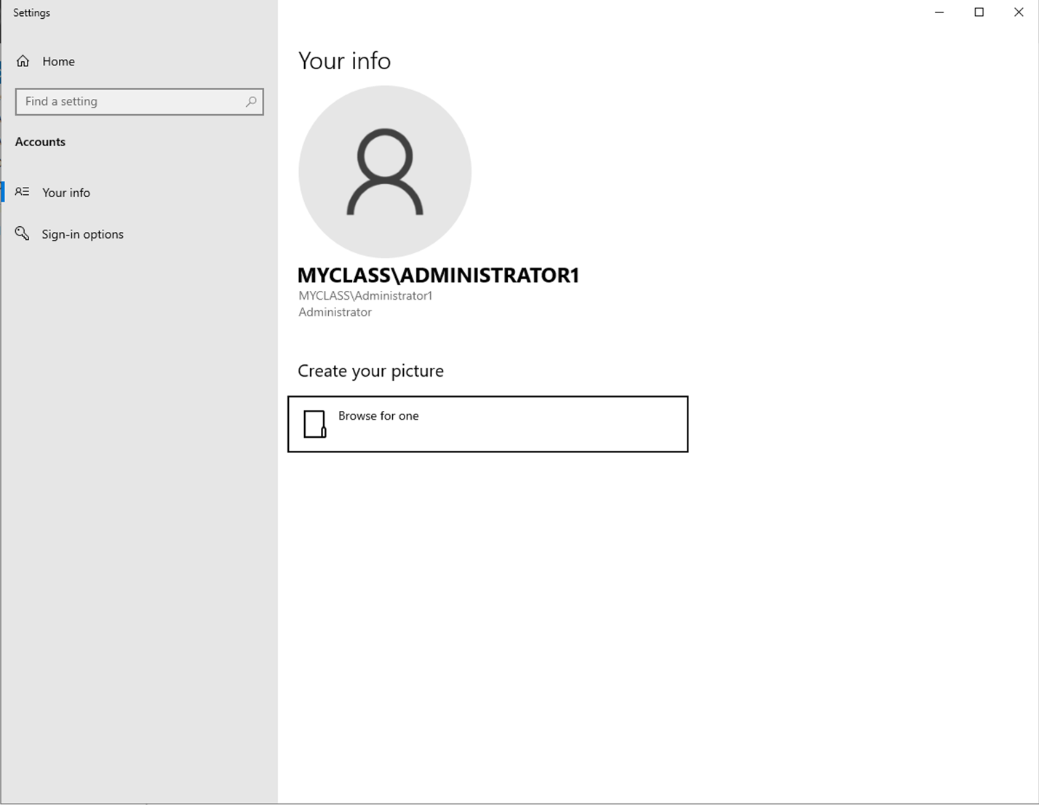**2.3 Create Organizational Units (OUs)**

I created the required OUs:

* **STAFF**
* **STUDENTS**

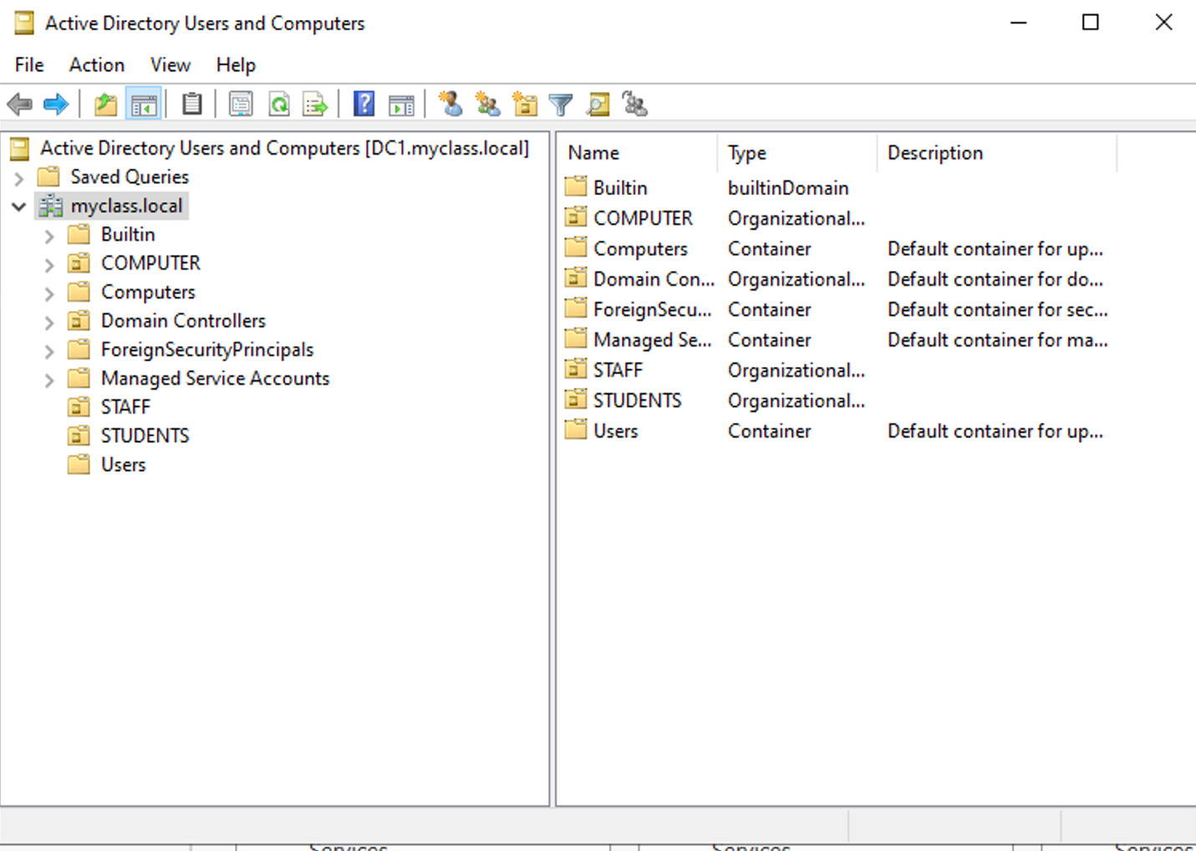

**3. DNS Server Configuration and Validation**

DNS is critical for domain joining and Group Policy.  
Initial testing showed proper operation:

**3.1 DNS Working Correctly**

Commands:

nslookup dc1.myclass.local

ping dc1

Both resolved correctly.

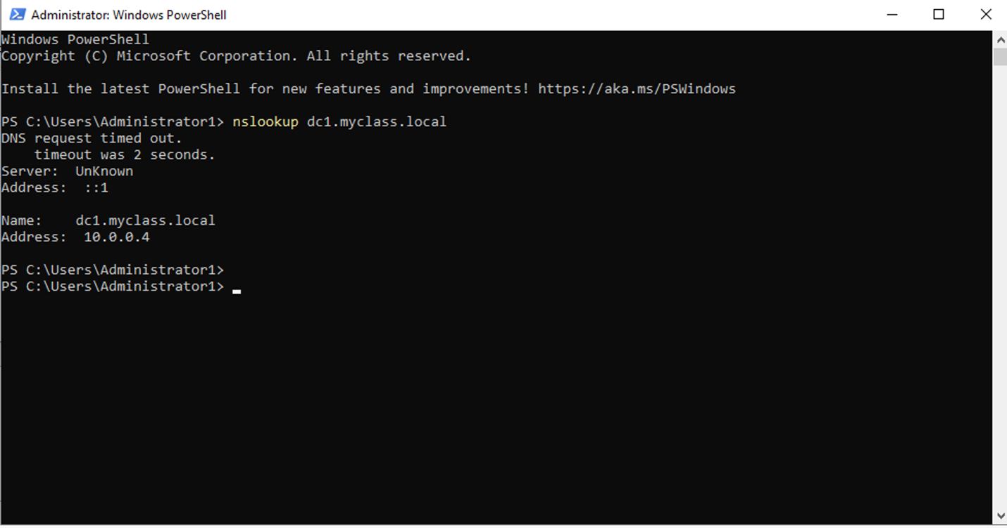  
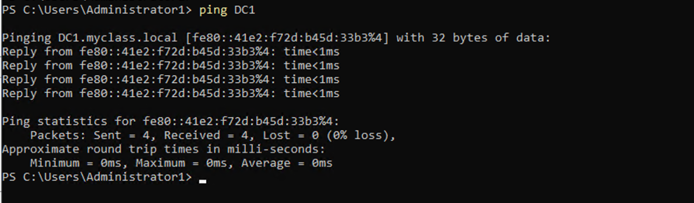

**3.2 DNS Issues Appeared When PC1 Used Wrong DNS Server**

Azure automatically assigned DNS **168.63.x.x**, breaking domain resolution.

Symptoms:

* “DNS server isn’t responding”
* nslookup timeouts
* Domain join errors

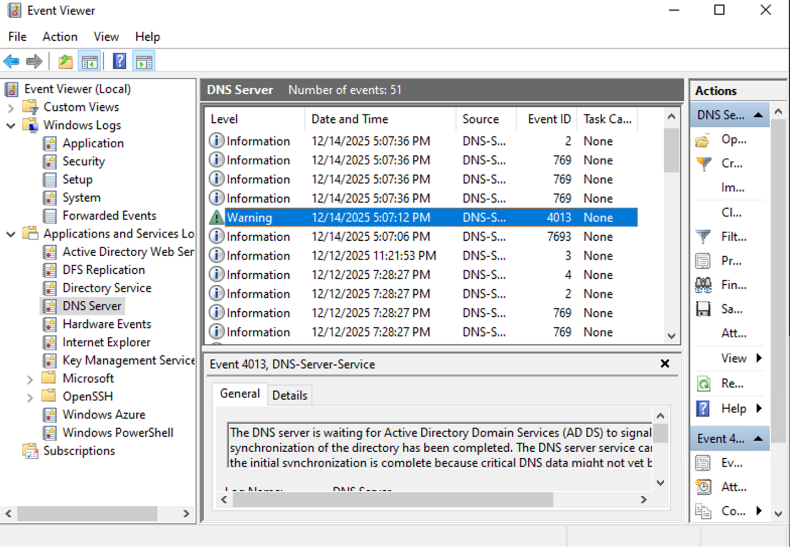

Fix:  
✔ Set DC1 static DNS to **127.0.0.1**  
✔ Configure DHCP Scope to assign **10.0.0.4** as DNS  
✔ Ensure client NICs use Internal Network / same vSwitch

**4. DHCP Server Configuration**

**4.1 Install and Authorize DHCP**

Once deployed, IPv4 was configured with a custom scope.

  
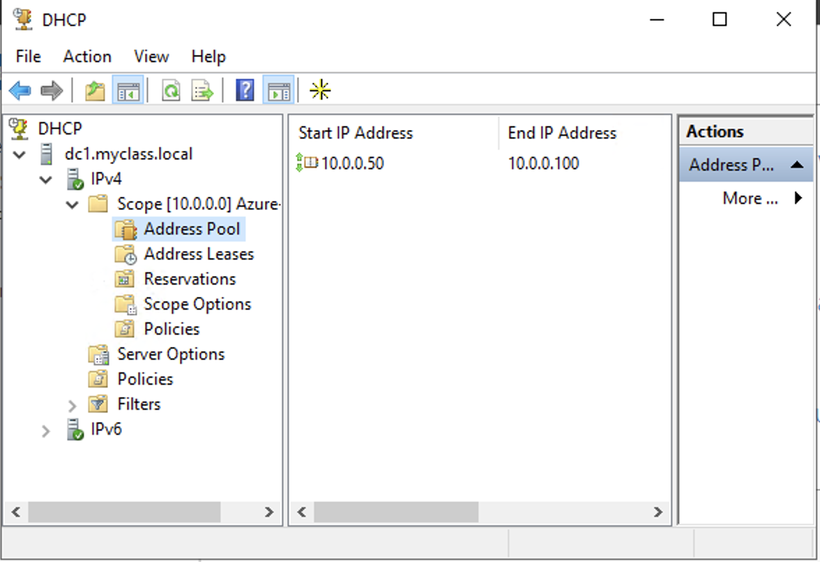

**4.2 Create DHCP Scope**

Scope: **10.0.0.50 – 10.0.0.100**  
Subnet mask: **255.255.255.0**

No exclusions were needed.

DHCP now issued correct DNS (10.0.0.4):

However, early in the lab Azure DHCP overrode it

**5. Client PC Setup and Domain Join**

**5.1 PC’s Initial Networking**

Before fixes, the client:

* Had correct IP (10.0.0.5)
* Had wrong DNS server (168.63.x.x)
* Could not ping DC1 (100% loss)

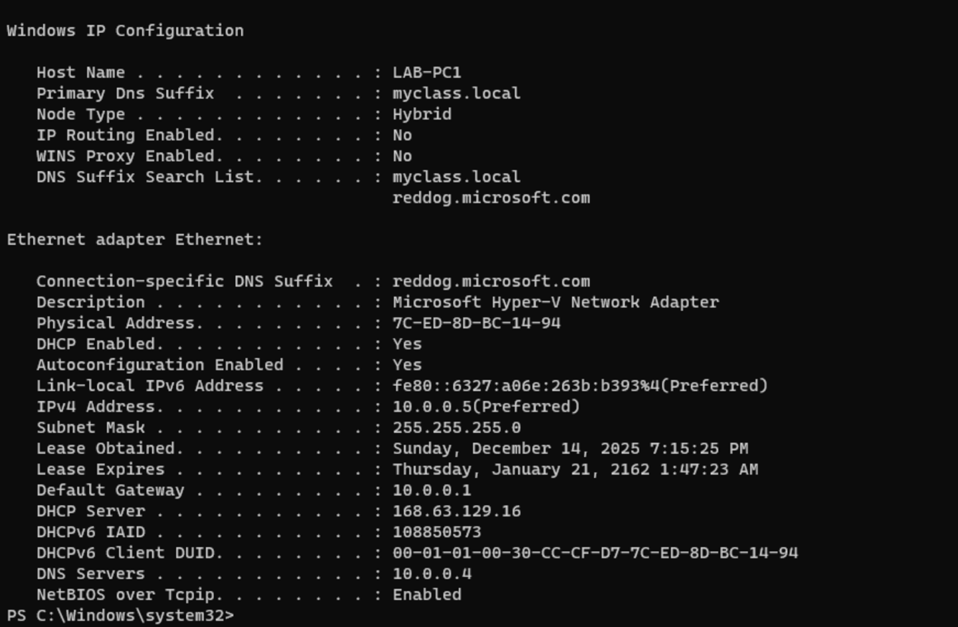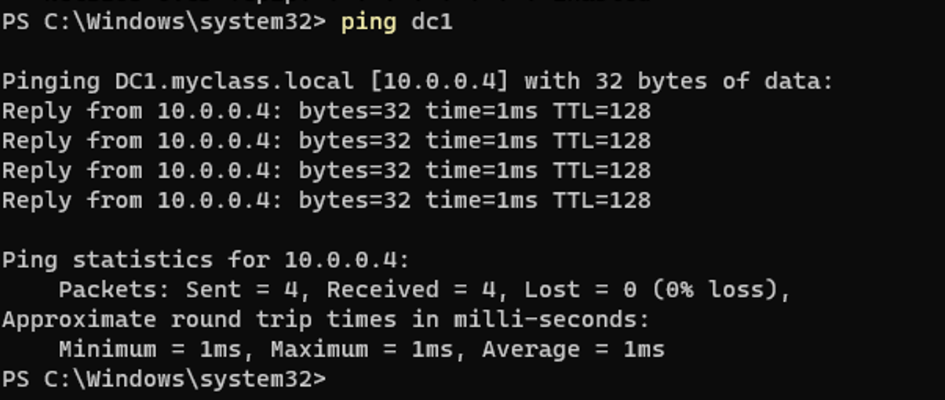

**5.2 Domain Join Attempts Failed**

Errors included:

* “DC for myclass.local could not be contacted”
* SRV record lookup failure
* Timeout errors

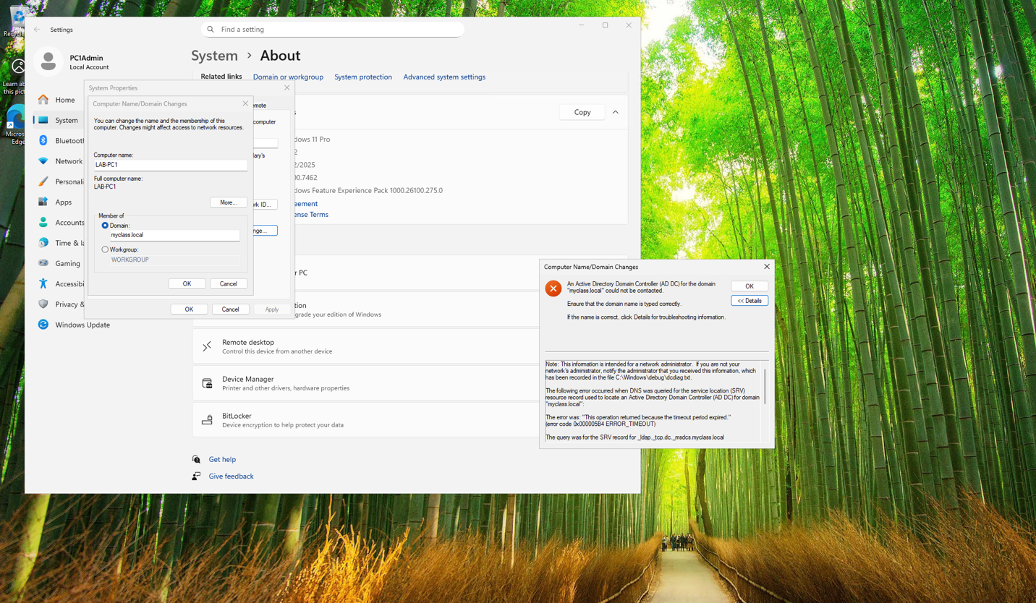

**5.3 Final Network Fix & Successful Domain Join**

After DHCP and DNS corrections:

* PC1 received DNS 10.0.0.4
* nslookup succeeded
* Domain join completed successfully

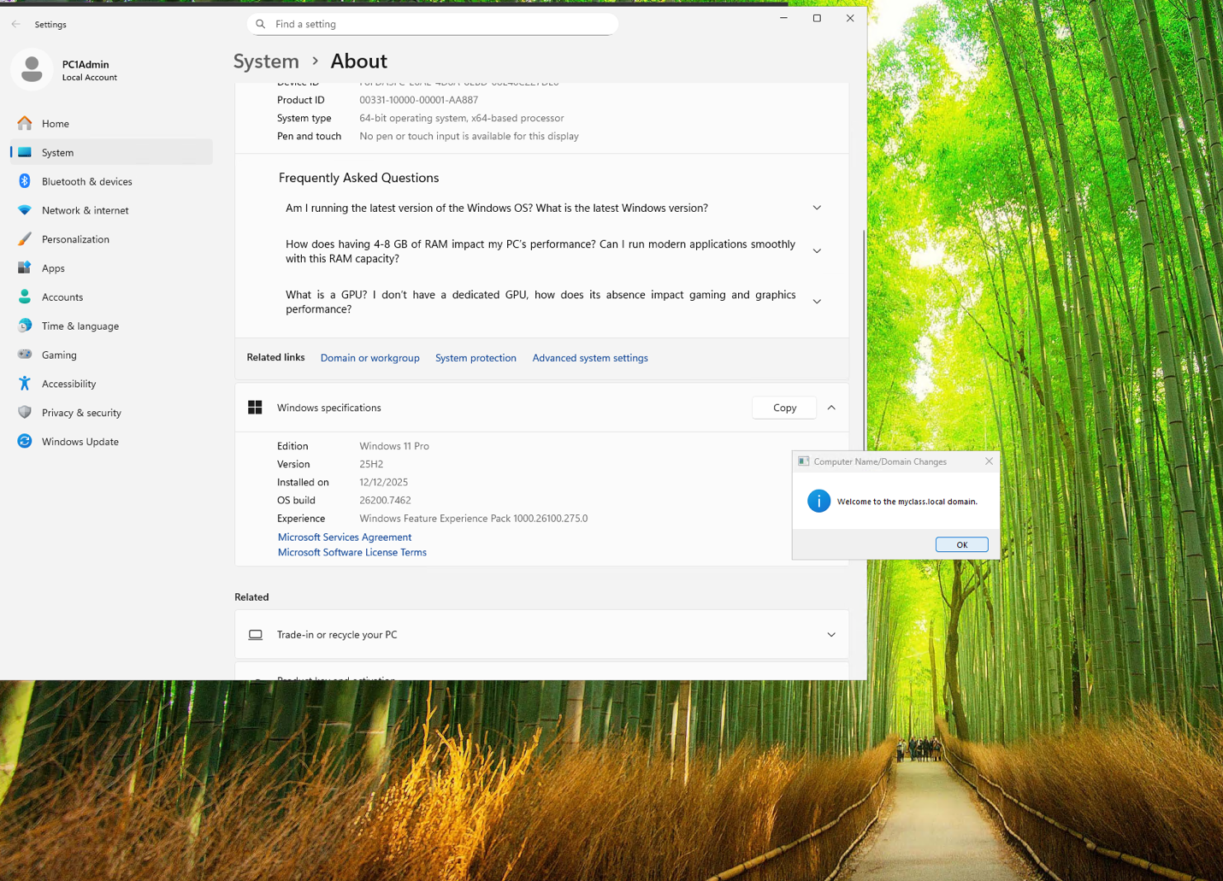

**6. IIS Web Server Setup**

**6.1 Install IIS Role**

With IIS installed, I created a basic index.html file in:

C:\inetpub\wwwroot

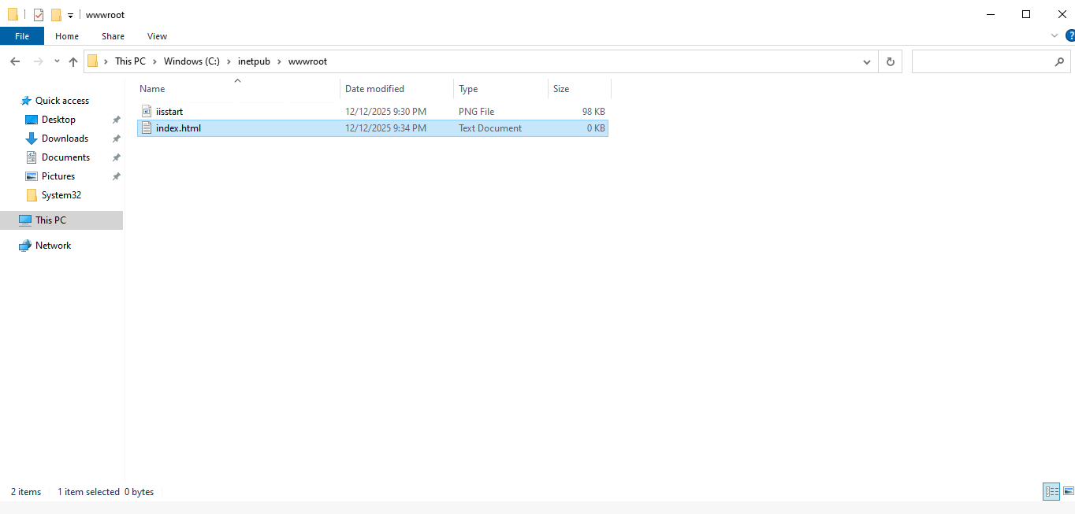

**6.2 Troubleshooting Errors**

Initial errors:

* **403 Forbidden** — no default document
* **404 Not Found** — file naming error (index.htm vs index.html)

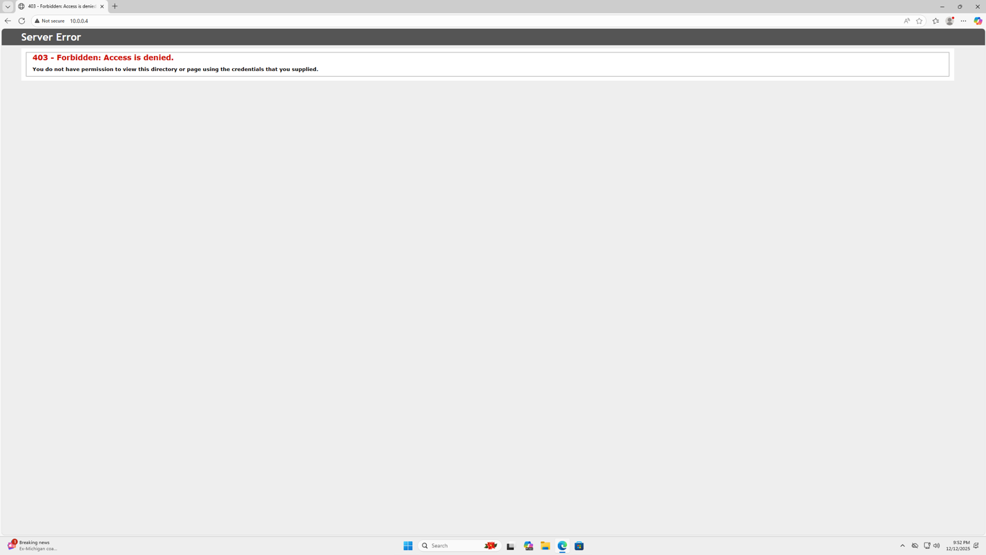  
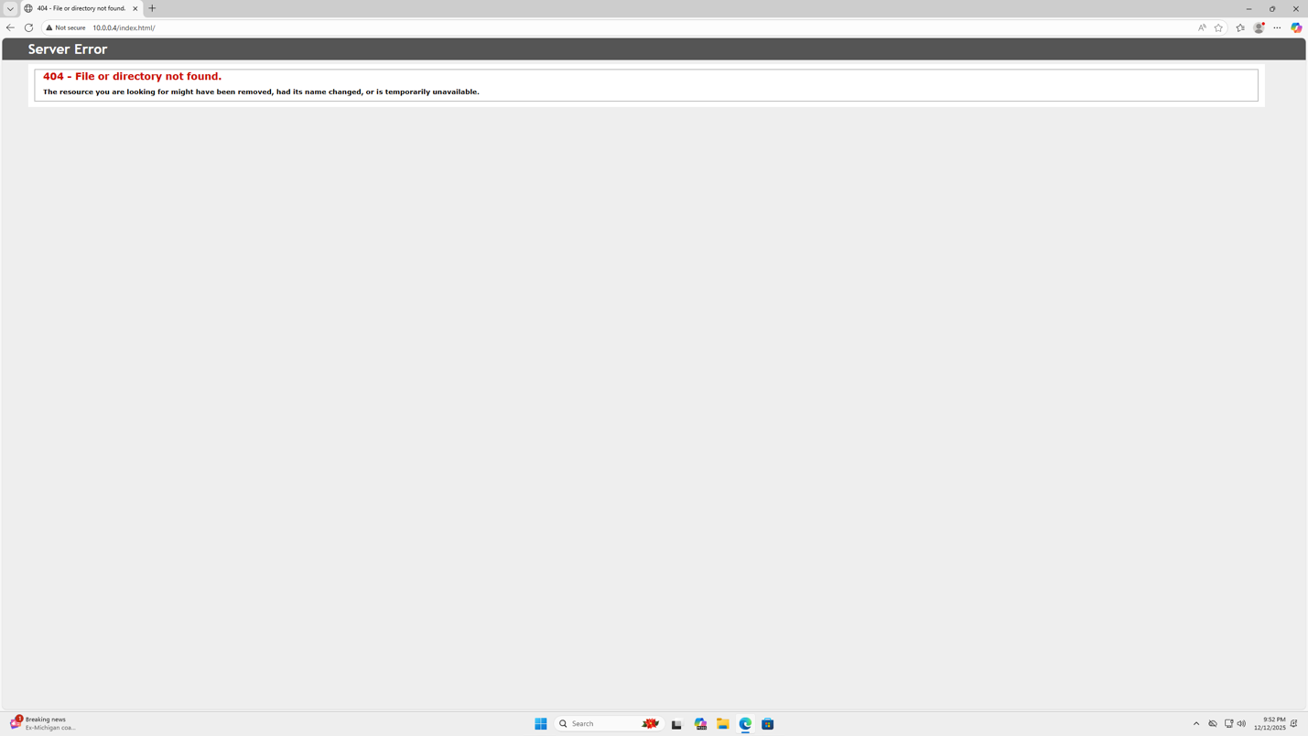

**6.3 Successful IIS Website**

After correcting the file:

* Website loaded from DC1
* Website loaded from LAB-PC1

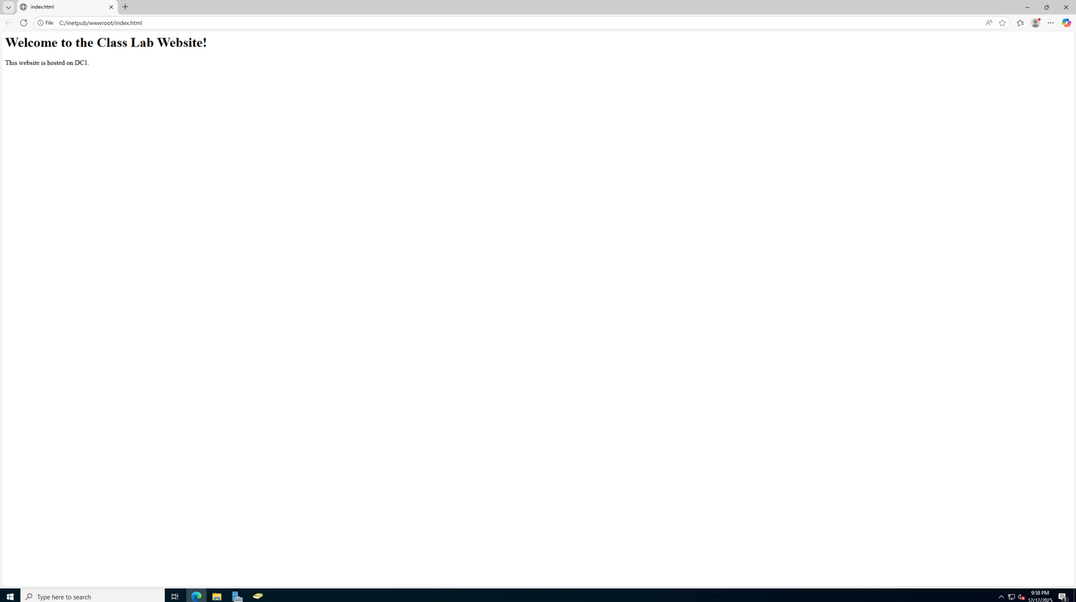

**7. Group Policy (GPO) Configuration**

**7.1 Student Policy Created**

In the **STUDENTS** OU:

* Linked a GPO named **Student Policy**
* Disabled Control Panel for student accounts

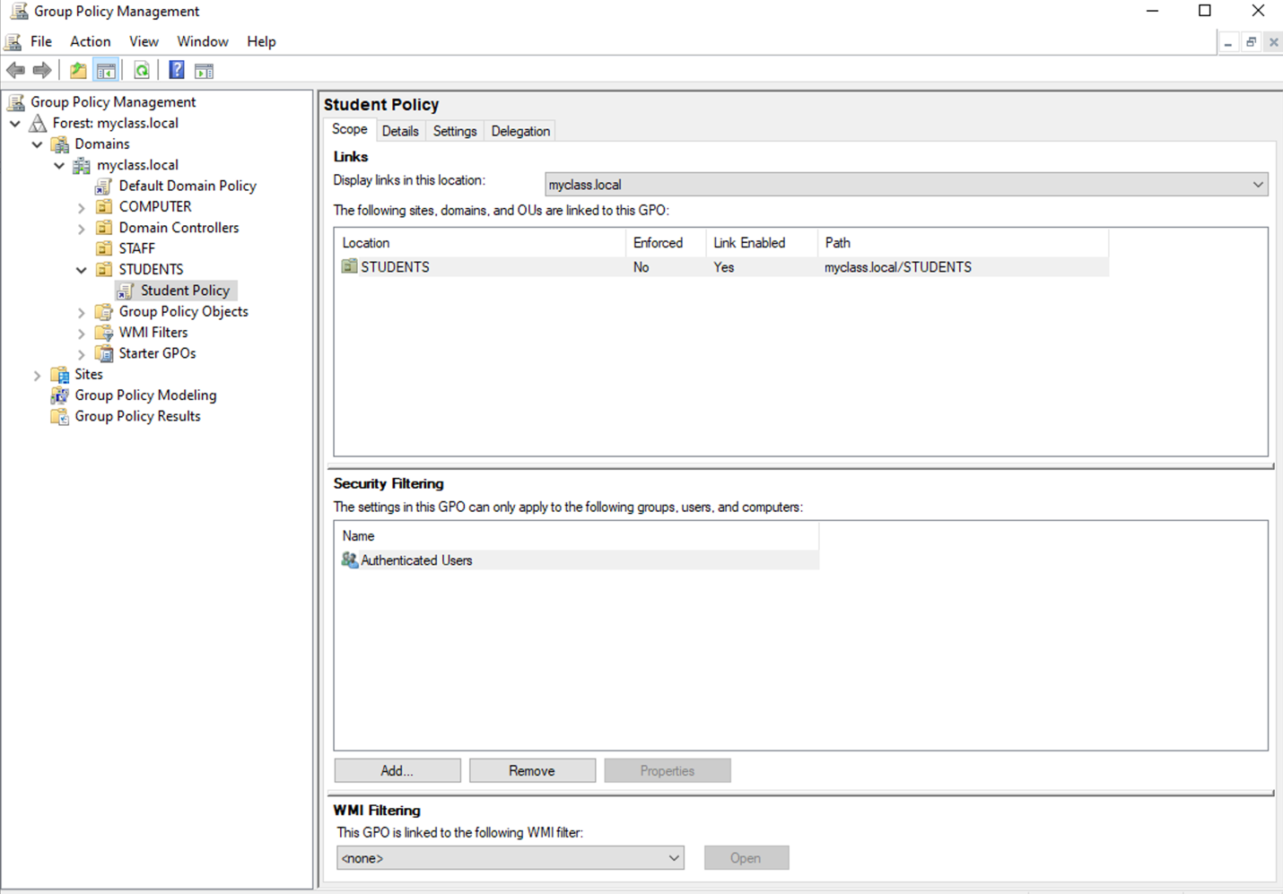

**7.2 GPO Validation**

Logged in as Student01:

Attempting to open Control Panel produced:

❌ “This operation has been canceled due to restrictions…”

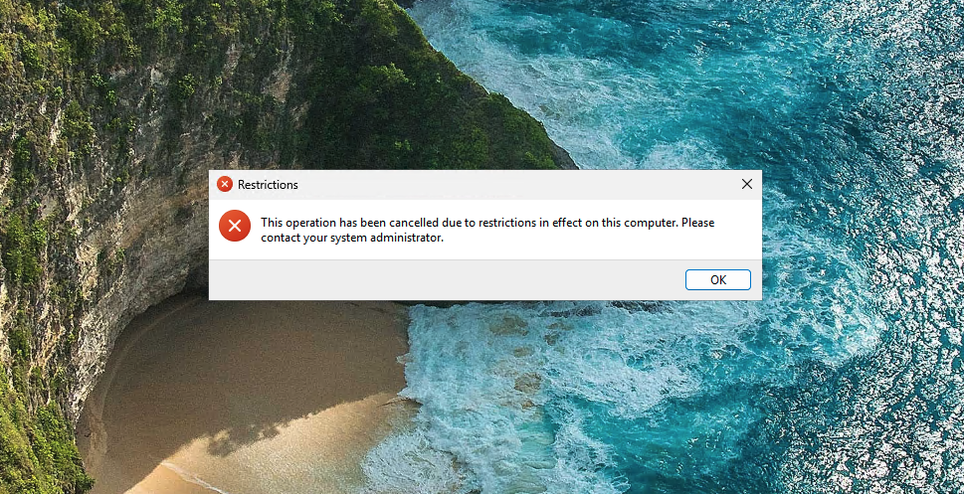

**7.3 gpresult Verification**

Using:

gpresult /r

I verified that Student Policy applied.

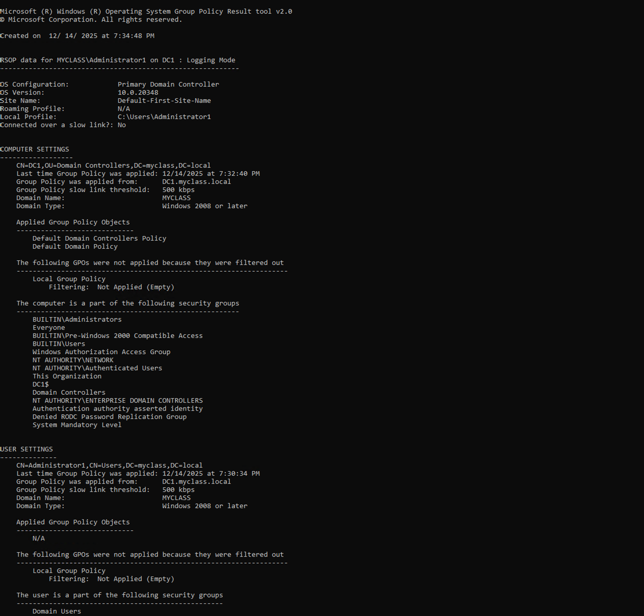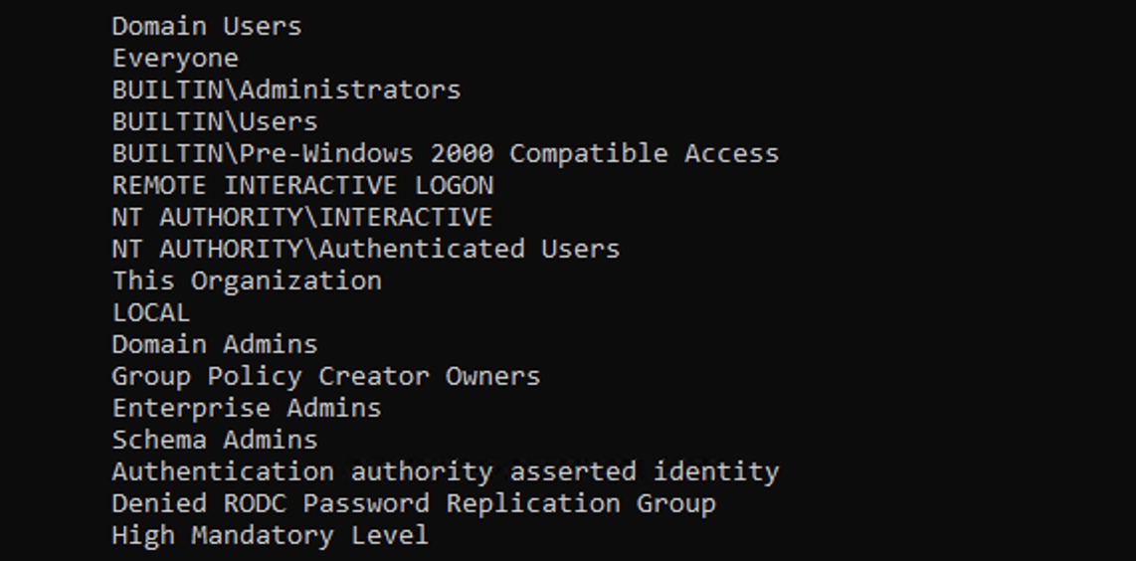

**8. Troubleshooting Summary**

Throughout the lab I encountered and resolved several issues:

**8.1 DNS Troubleshooting**

Symptoms:

* nslookup timeout
* Wrong DNS suffix
* “No such domain”

**8.2 NIC State Problems**

ipconfig /release failed due to NIC being externally controlled.

**Fix**: renew the ip within the serial console.

**8.3 Azure Interference**

Azure DHCP assigning wrong DNS suffix:

Fix:  
Switch NIC to **Internal Network** or **same Hyper-V vSwitch**.

**9. VirtualBox / Azure Issues (Documented for Completeness)**

Even though ultimately everything worked, these issues were part of the process and useful for documentation.

**9.1 VirtualBox Misconfiguration**

NIC was set to **NAT**, preventing domain communication.

**9.2 Azure VM Password/Boot Errors**

Errors included:

* Must change password before login
* Serial console bluescreen (NMI_HARDWARE_FAILURE)

**9.3 Azure Marketplace VM Selection**

Documentation of chosen Windows 10/11 images.

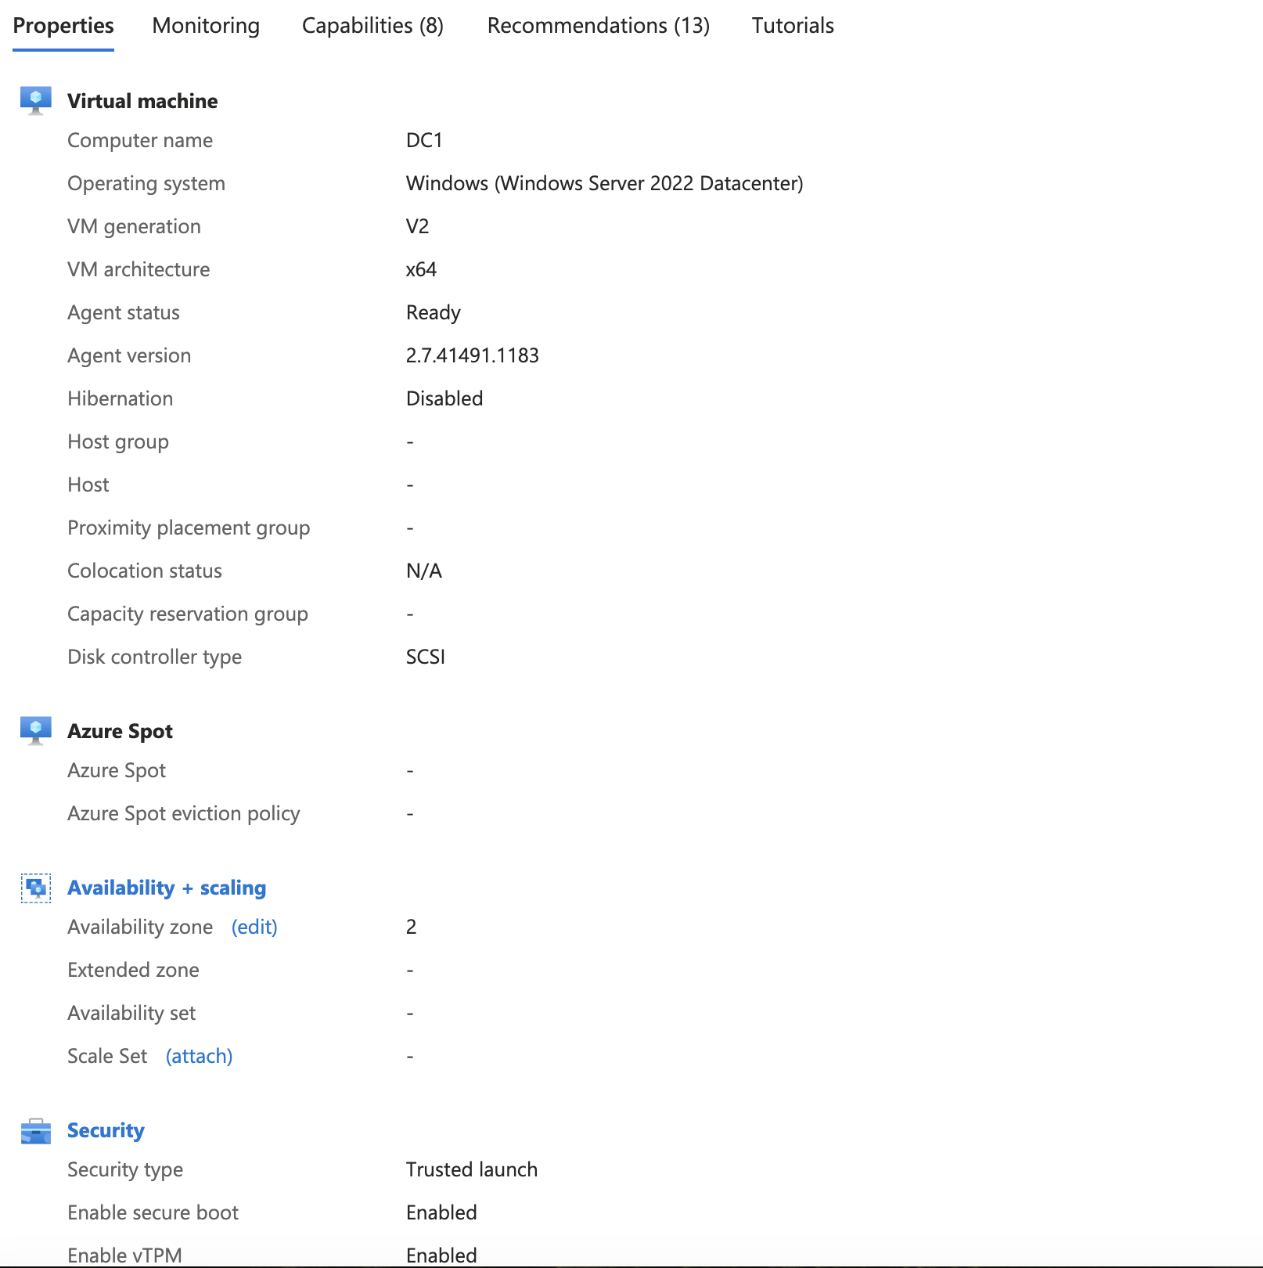

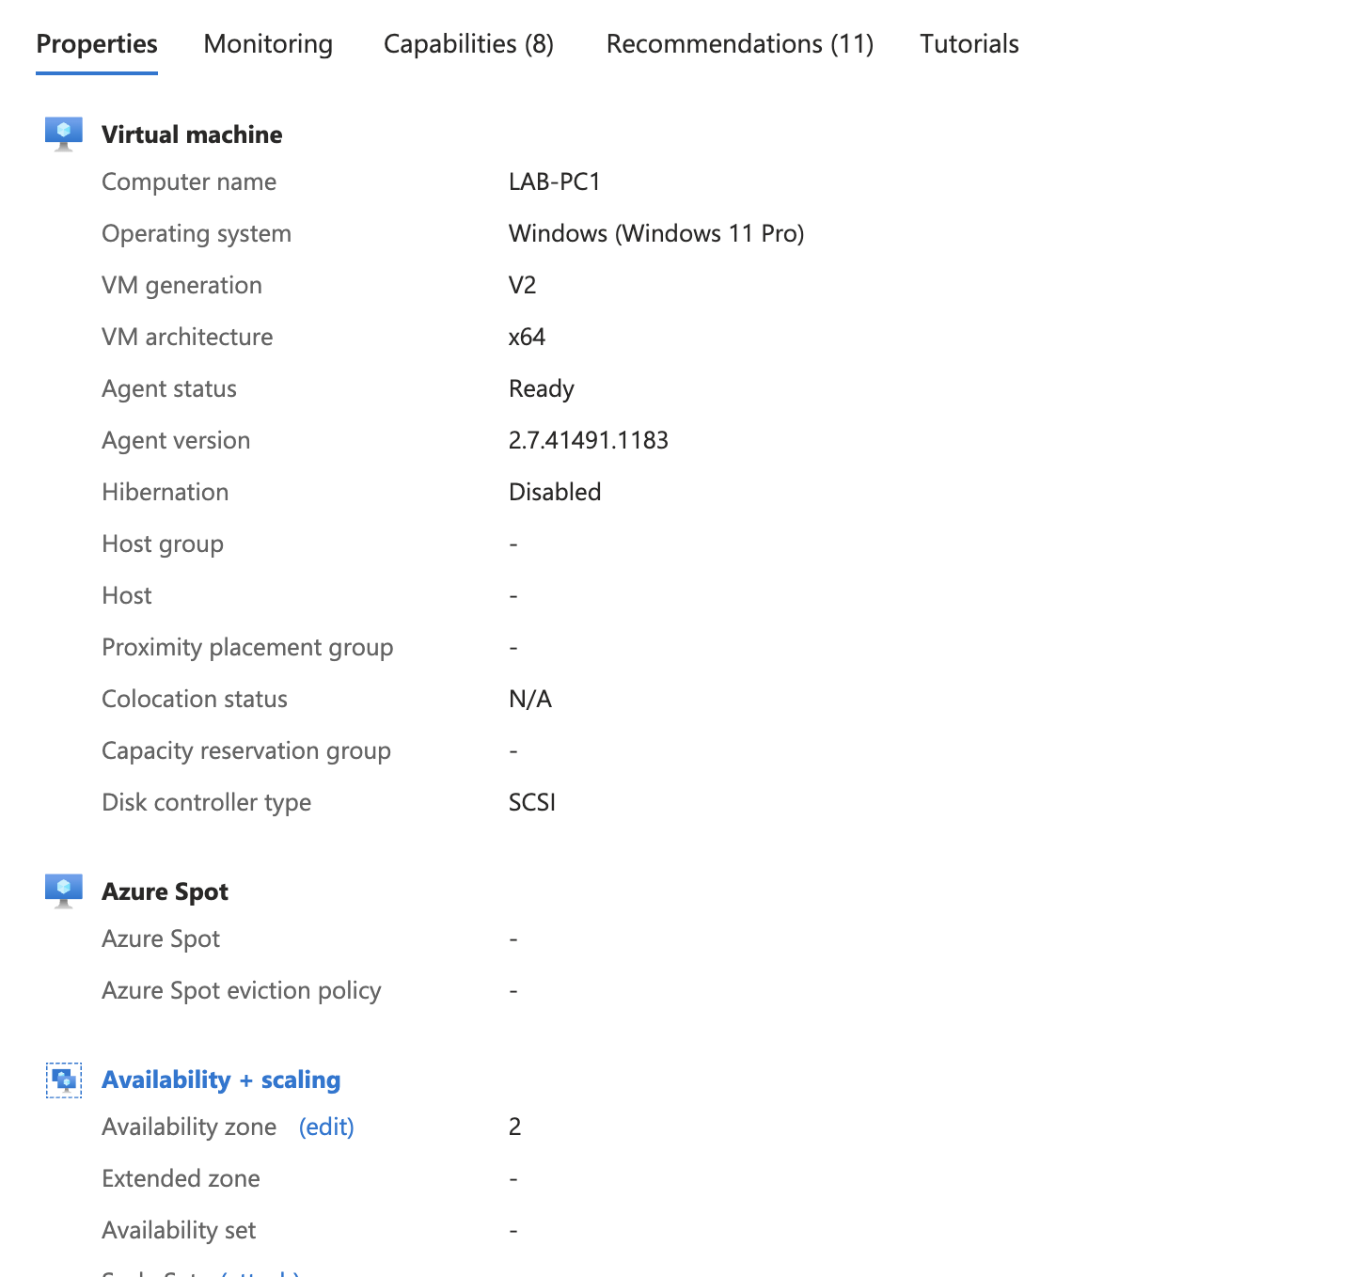

**10. Final Lab Checklist (Completed)**

| **Requirement** | **Status** |
| --- | --- |
| Server named DC1 | ✔ Done |
| Correct static IP | ✔ SRV-01 |
| Active Directory installed | ✔ ADDS-03 |
| DHCP configured & running | ✔ DHCP-05 |
| PC1 + PC2 renamed | ✔ |
| Both PCs joined to domain | ✔ PC-06 |
| Domain user login works | ✔ |
| IIS webpage loads from server | ✔ IIS-04 |
| Group Policy applied | ✔ GPO-03 |
| **REFLECTION:**  1. Why does DNS need to point to the domain controller?  - For your internal network to function properly, all domain-joined devices must use the internal DNS hosted by your domain controllers to find each other and the essential Active Directory services. The internal DNS can then use forwarders to look up external websites on the public internet |  |

2. Why is DHCP useful in networks?

- it automates the time-consuming and error-prone process of assigning IP addresses and other network configuration settings to devices. This automation simplifies network administration and allows devices to connect to the network seamlessly.

3. What is one thing you found challenging and how did you solve it?

- I had trouble getting the windows iso file to work with my MacBook type so instead I used azure VMs and followed the instructions for the lab.